“And the peace of God, which surpasses all comprehension, will guard your hearts and your minds in Christ Jesus.” -- Philippians 4:7
- Please show all your work! No partial credit will be given for incorrect answers with no work shown. Please draw a box around your final answer.
- Calculators are permitted, but no notes, text, laptops, PDAs, or electronic dictionaries.
- Cell phones should be muted and left in your pocket or bag.
Total marks: 60

- 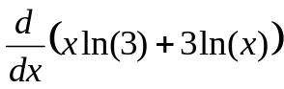 [2]
ln(3) + 3/x
- 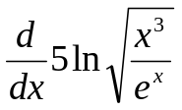 [3]
(5/2) ( 3/x – 1 )
- Find dy/dx if: y = ln(xy) [3]
y / ( x (y – 1) )
- 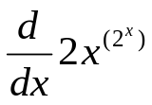 [3]
(notation: 2^x = 2^{x})
2 x^{2^x} [ ln(2) 2^{x} ln(x) + 2^{x}/x ]
- 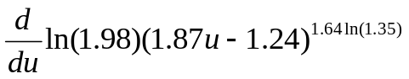 [3]
ln(1.98) * (1.64 ln(1.35)) *
(1.87u – 1.24)^{1.64ln(1.35) – 1} (1.87)
- 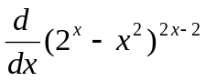 [4]
(2^{x} – x²)^{2x-2} [ 2ln(2^{x} – x²) +
(2x – 2) * 1/(2^{x} – x²) * (ln(2)2^{x} – 2x) ]
- Let 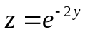, 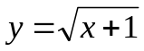, and 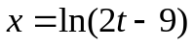. Find dz/dt when t=5. [3]
dz/dy = -2e^{-2y}
dy/dx = 1/2sqrt(x+1)
dx/dt = 2/(2t – 9)
@t = 5, x = 0, y = 1, z = e⁻²
dz/dt = (-2e⁻²)(½)(2)
= -2e⁻²
≈ -0.2707

- Find the equation of the line tangent to the curve 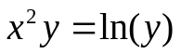 at the point (0, 1). [4]
dy/dx = 2xy² / (1 – x²y)
@ (x=0, y=1): dy/dx = 0
tangent line is just y = 1
- If 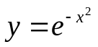, find y’’’ (triple derivative!). [4]
y’ = -2x e^{-x^2}
y’’ = (4x² – 2) e^{-x^2}
y’’’ = (-8x³ + 12x) e^{-x^2}
= – 4x (2x² – 3) e^{-x^2}
- The demand equation for a product is 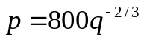.
  - At what price will the demand be 1000 units? [1]
p = $8.00
  - Find the point elasticity of demand when q=1000. Is the demand elastic? [4]
dp/dq = 800(-2/3)q^{-5/3}
@ q=1000: dp/dq = -2/375 ≈ -0.00533
η = (p/q) / (dp/dq)
= (8/1000) / -0.00533
= -1.5: elastic
- Assume that the total cost is modelled by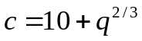 and the revenue is modelled by 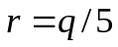. Use Newton’s method to approximate the break-even point. Start with an initial guess of q₀ = 200 and show two steps (i.e., find q₁, q₂). [6]
f(x) = (q/5) – (10 + q^{2/3})
f’(x) = (1/5) – (2/3)q^{-1/3}
x₁ = x₀ – f(x₀)/f’(x₀)
= 200 – f(200)/f’(200)
x₁ ≈ 248.8307
x₂ ≈ 246.6469
(which is nearly the exact answer)
- Consider the function 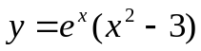.
  - Find all x and y intercepts. [2]
y-int: -3; x-int: +/-√3
  - Find all vertical, horizontal, and diagonal asymptotes, if any. [2]
None
  - Find all zeroes and discontinuities of the function, if any. [2]
x = +/-√3 (no discontinuities)
  - On what intervals is the function positive? Negative? [2]
(-∞, -√3): +. (-√3, √3): –. (√3, ∞): +
  - Find the first derivative dy/dx. [2]
dy/dx = e^{x} ( x² + 2x – 3 )
  - Find all critical points. [2]
x = -3, 1
  - On what intervals is the function is increasing? Decreasing? [2]
(-∞, -3): incr. (-3, 1): decr. (1, ∞): incr
  - Find the second derivative d²y/dx². [2]
d²y/dx² = e^{x} ( x² + 4x – 1 )
  - Find all inflection points. [2]
x = -2 +/- √5
  - On what intervals is the function is concave up? Concave down? [2]
(-∞,-2 - √5): up. (-2 - √5, -2 + √5): down. (-2 + √5, ∞): up

